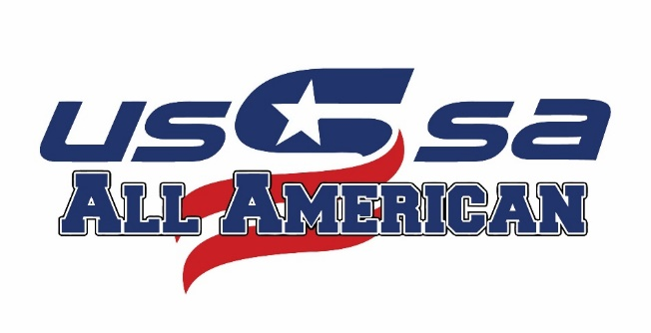

Welcome to the 2019 USSSA All American Games hosted at USSSA Space Coast Complex! We are excited to be a part of your summer. The brand new USSSA Space Coast Complex is located on 85 acres near the coast of Florida, featuring 15 all AstroTurf fields, three championship stadiums with state-of-the-art HD video boards, covered seating and excellent concessions at every quad. The complex is a short drive from Florida’s pristine beaches, shopping and restaurants to make your experience full of competition and fun.

Throughout 2019, USSSA Fastpitch hosted 24 tryouts across eight regions over the United States drawing nearly 2000 participants from all over the nation. 1144 athletes ranging from 9 to 14 years old were selected by USSSA Pride professional softball players to represent each region for their respective age group and to participate in the All American Games. Two teams in each age group were created per region, which include the Atlantic, Central, Great Lakes, Southeast, Midwest, Far West, Northeast, and Northwest, generating an 88 team tournament here at the USSSA Space Coast Complex in Viera, Florida.

USSSA All American Game athletes were hand-picked from all over the nation to travel to the eastern coast of Florida for a week-long tournament at the brand new USSSA Space Coast Complex. Each team is coached by current and former NCAA softball athletes compete against their peers from around the United States.

The event kicks off the July 22nd with team check-in and practices allowing the athletes to meet each other and their coaches for the event. USSSA Fastpitch is excited to welcome you to the 2019 All American Games and expect this year to be as exciting as any.

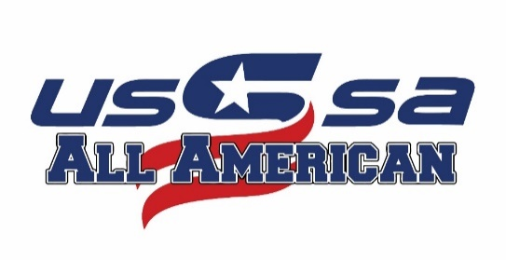
Participant and Parents Code of Conduct

The goal of the United States Specialty Sports Association (USSSA) is to offer our members a quality product in all aspects of the USSSA Programs. This begins with the service and cooperation they receive from our state and national office and ends with their experience on the playing field. USSSA and is committed to providing athletes the tools and the competitive platform by which they can accomplish their dreams in softball and in life. To this end we are committed to making the USSSA All American Games a positive one, in terms of competitiveness and an overall enjoyable experience for everyone involved and that nothing which occurs during the operation of these games reflects negatively toward the USSSA, and the All American Games.

1. Parents and athletes will maintain high standards of moral and ethical conduct that includes self-control and responsible behavior. Both athletes and parents must display courtesy and good manners and consider the physical and emotional well-being of others.

2. Parents and athletes will not swear, use abusive language or display disruptive behavior, including behavior that is dangerous to self or others, including acts of violence, harassment, and physical or sexual abuse.

3. Parents and players will respect the officials and their authority during games and will never question, discuss or confront coaches at the game, and will take time to speak with coaches at an agreed upon time and place with the attendance of a tournament director.

4. The head coach will be the sole decision maker in all aspects of the game. He/she will be the only person making the lineups, making changes to the lineup and determining all game management facets. They may ask for the assistance of a parent to help in activities such as team warm-ups, managing the dugout, or coaching first base but that is completely at the discretion of the head coach. At no point will the parents have any say in how the game is managed or who is playing in the game.

5. Parents are asked to stay away from the dugout during practices and games unless of an emergency situation, or asked for assistance by the head coach.

6. Failure to adhere to these or any other rules and procedures as set forth in an USSSA sanctioned event may result in actions taken against the individual held responsible. Such penalties include reprimands, probation, suspension (game, event, year or multi-year) or permanent expulsion from USSSA sanctioned events.

Participants Name:________________________________________________________________________

Parent’s Signature:______________________________________________________Date:______________

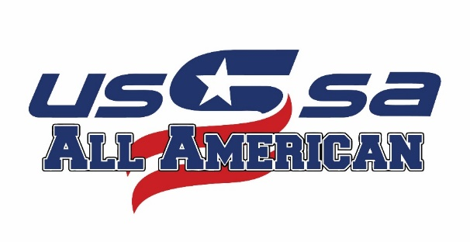

2019 Fastpitch All American
Games Rules Addendum

All games will be played by USSSA rules, with the following exceptions:

- Home team will be the official scorekeeper in all tournament games. A home
team representative will complete the scorebook for that game.
- The tournament will provide all game balls and umpire fees.
- Pre-game conference and coin flip between manager and umpires will take place
5 minutes prior to the start of the game.
- All equipment must be USSSA approved (bats), not metal cleats are allowed.
- No organized infield practice before the games. Teams may warm up beyond the
baselines or in foul territory. No live batting practice is allowed on the field or in the complex at any time. Batting cages are available in the Red Quad. No hitting into fences.
- Time limit for all games is 90 minutes. Time begins after the pre-game
conference. Time limit could change in case of tournament interruptions. All teams should be prepared to start their pool game up to 10 minutes early in case we are ahead of schedule.
- Pool Play Games can end in a tie at the end of regulation.
- Bracket Play Games will go to ITB at the end of regulation until a winner is
declared.
- There will be NO run rule. Games will go 90 minutes or 7 innings.
- Team coaches may consult with the umpires; players, sponsors and other parties
are to keep out of discussions. The head coach is responsible for all communications, even those by other coaches.
- No smoking or tobacco use on the field or in the dugouts.
- 10. Batting Line-Ups
- Coaches will set a batting line-up prior to the beginning of the event.
- All players will bat in the line-up and are expected to hit unless they are a pitcher who does not hit and expresses otherwise. Hitting line ups will be set once for pool games and once for bracket games. The batting line up will be set and continue to be revolving until re set for bracket play.
Example: Game ends with the 4th batter being the last out of the game. At the start of the next game the 5th batter in the lineup will lead off the game.
- If a player is forced to leave the game, the following protocol will be
followed:
- Injury:
Batter: If a batter cannot fulfill her time at bat due to injury or
illness, that player will be eliminated from that entire game. Her spot will be skipped in the batting order. Teams will not be required to take an automatic out UNTIL they drop below 9 players.
Runner: If a runner cannot continue her time on the bases, that player will be substituted with the last batter not on base. She will not be allowed to participate in the remainder of the game. The line-up will compress when her spot comes to bat.
- Ejections: A player ejection while roster batting will result in the team losing that player for the entire game. Her spot in the batting order WILL be an automatic out.
- Courtesy runner for pitcher and catcher, last batted out.
- Due to all players being in the line-up, there will be free defensive substitutions.
- The following procedure will be used to determine the seeding after pool play:
  - If three or more teams are tied with the same record in a division, head-to-
head may or may not be used to break ties.
  - Once a level of tie-breaker is used, we DO NOT revert back to any steps
of the tie-breaking procedure. We will continue on down the list until all ties are broken.
  - Highest Winning Percentage (number of wins divided by number of games
with a result (ties eliminated form formula))
  - Most Wins
  - Head-to-Head Games
  - Runs allowed per game
  - Runs differential (+/- of 8 runs per game)
  - Coin Flip

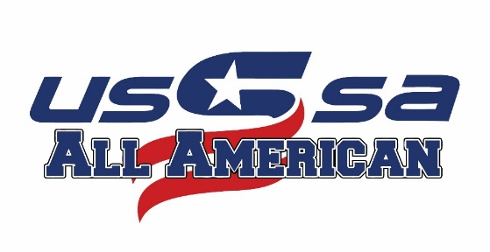
INCLEMENT WEATHER
VIERA, FLORIDA JULY 22ND- JULY 27TH _______________________________

In the event of inclement weather, we have a weather app that will help communicate to you the changes that are occurring in the event. You will be able to subscribe via an Android or IPhone App to receive all updates on your phone. Read through the options and process here to see how this new feature will help keep you informed from the ballpark.

Website:
Log onto the website at www.RainoutLine.com. Search VA USSSA
- Choose our name from the list of groups
- Click on the star to keep us locked in as one of your favorites
- Select the park you wish to view and update to read our weather updates

Mobile Phone App
- Download the appropriate platform App (iPhone or Android)
- Search for VA USSSA
- Select and mark as your favorite with the star
- Once you choose VA USSSA you will see the complex (Space Coast Complex) as the park location for the All American Game Event
- Text/Email Notifications
- Please make sure you have the notifications turned on to get the most recent updates that we provide for weather.

Search:
VA USSSA

Phone Number:
(804) 776-2256

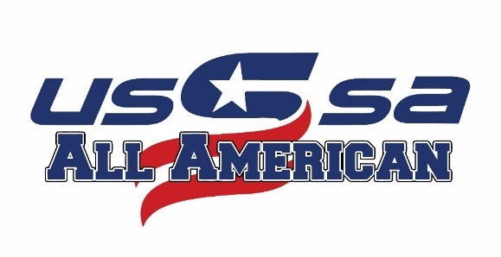
SOCIAL MEDIA
VIERA, FLORIDA JULY 22ND- JULY 27TH
________________________________

Follow Us on Social media to WIN prizes during the event.

@usssafastpitch @usssaspacecoast

@usssafastpitch @usssaspacecoast

@usssafastpitch @usssaspacecoast

Be sure to use the All American Games snap chat filter and tag us on other Social Media platforms!!!

All American Games Hashtags

#AAGFP2019 #playusssa #wheretheprosplay #usssafp
Meetings for Fun
Location: Club House Red Quad
________________________________

Tuesday July 23rd

Time: Seminar: Location:

9:00am Pride Chalk Talk (Kelly Kretschman, Amanda Lorenz) Clubhouse Red Quad
10:00am NCSA Clubhouse Red Quad
11:00am Pride Chalk Talk (Chelsea Goodacre, Sydney Romero) Clubhouse Red Quad
1:00pm NCSA Clubhouse Red Quad
2:00pm Pride Chalk Talks (Megan Wiggins, Chip Bennett) Clubhouse Red Quad
5:00pm NCSA Clubhouse Red Quad

Wednesday July 24th

Time: Seminar: Location:

10:00am NCSA Clubhouse Red Quad
1:00pm NCSA Clubhouse Red Quad
5:00pm NCSA Clubhouse Red Quad

***Each team will be mandatory to attend at least one of the NCSA recruiting talks your coach will inform you of which chalk talk and NCSA seminar you will be attending Monday at team practice.
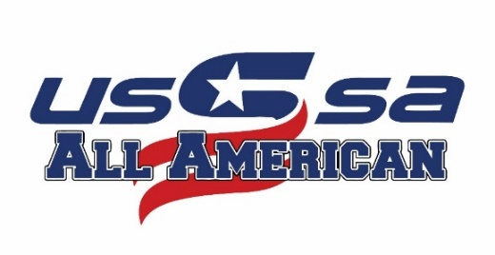
Learn From the Pros- Pride Camp
Date: July 27th
Time: 9am-1pm
Link: http://usssa.com/clinics/events
Cost: $125
Location: Space Coast Stadium

Contact Sheet

